New Issue Alert | 18 December 2023

  Dear Reader,
  We are pleased to deliver your requested table of contents alert for Welding in the World. Volume 68, Issue 1 is now available online.
  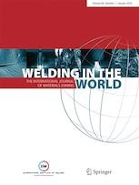

In this issue

Research Paper

  Joining of graphite to electrical pure iron using AgCuTi filler alloy and analysis of residual stress within the brazed joint
  Wen-Wen Li, Bo-Hong Li, Wei Mao, Jian Yang, Bo Chen, Hua-Ping Xiong, Ye Liu
  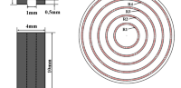

» Abstract » Full text HTML » Full text PDF

Research Paper

  Impacts of diffusion brazing time on mechanical properties of Nicrofer 5520 superalloy joint by Ni-15Cr-3.7B filler metal
  Ali Nasajpour, A. Farzadi, Seyyed Ehsan Mirsalehi
  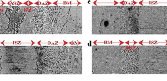

» Abstract » Full text HTML » Full text PDF

Research Paper

  Effect of bonding temperature on microstructure and mechanical properties of Inconel 718 alloy transient liquid phase joints
  Jianguo Chen, Ji Dong, Yushun Wei, Yong Guo, Xuan Wang
  

» Abstract » Full text HTML » Full text PDF

Research Paper

  Influence of iron on the structure and strength of the Kovar to stainless steel joints by using Cu–Mn–Co–Fe brazing filler metal
  S.V. Maksymova, P.V. Kovalchuk, V.V. Voronov
  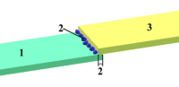

» Abstract » Full text HTML » Full text PDF

Research Paper

  In situ X-ray phase contrast imaging of the melt and vapor capillary behavior during the welding regime transition on aluminum with limited material thickness
  W.-S. Chung, M. Hummel, C. Spurk, A. Häusler, A. Olowinsky, C. Häfner, F. Beckmann, J. Moosmann
  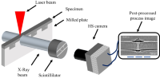

» Abstract » Full text HTML » Full text PDF

Research Paper

  Comparative study between TIG-MIG hybrid and MIG welding of 1.4462 duplex steel joints
  S. Weis, R. Grunert, S. Brumm, M. Halmaghi, U. Prank
  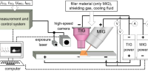

» Abstract » Full text HTML » Full text PDF

Research Paper

  Effect of CuZnAl particle addition on the microstructure and shear property of Cu/In-48Sn/Cu solder joints by transient liquid phase bonding
  Li Yang, Haodong Wu, Yaocheng Zhang, Kaijian Lu, Qiusheng Lin
  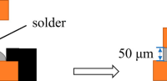

» Abstract » Full text HTML » Full text PDF

Research Paper

  Characterization of friction stir-based linear continuous joining of aluminium alloy to structural polymer
  Prabilson Khadka, Sean Varglund, Samuel Akinwamide, Pedro Vilaça
  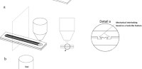

» Abstract » Full text HTML » Full text PDF

Research Paper

  Effect of temperature on wear and friction performance of WC-Co and Cr₃C₂ reinforced with 17-4PH Fe-based composite coatings
  T. V. Chandramouli, Sharnappa Joladarashi, M. R. Ramesh, Mohammad Rizwanur Rahman
  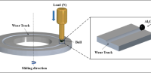

» Abstract » Full text HTML » Full text PDF

Research Paper

  Efficient prediction of residual stress in additive manufacturing based on semi-analytical solution
  Maohong Yang, Guiyi Wu, Xiangwei Li, Ruiyao Zhang, Shuyan Zhang, Honghong Wang
  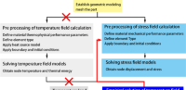

» Abstract » Full text HTML » Full text PDF

Research Paper

  Frontal pyrometric snapshot measurements of the keyhole wall temperature in laser welding of pure aluminium
  R. Pordzik, T. Mattulat, P. Woizeschke
  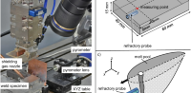

» Abstract » Full text HTML » Full text PDF

Research Paper

  Study on microstructure characterization and mechanical properties of AISI 444 ferritic stainless steel joint by high-frequency pulse K-TIG welding
  Zhihai Dong, Ye Tian, Tingting Hao, YiWen Li, JunYan Miu, XinYing Cui, Chenhe Chang, Yunlong Chang
  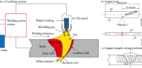

» Abstract » Full text HTML » Full text PDF

Research Paper

  Effect of post-welding heat treatment on microstructure and properties of electron beam welding joint of new high-strength TB18 titanium alloy
  Jian Long, Lin-Jie Zhang, Long Zhang, Miao-Xia Xie
  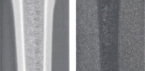

» Abstract » Full text HTML » Full text PDF

Research Paper

  Pre-melted electron beam freeform fabrication additive manufacturing: modeling and numerical simulation
  Xi Shu, Chunyu Wang, Guoqing Chen, Chunju Wang, Lining Sun
  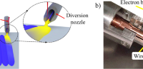

» Abstract » Full text HTML » Full text PDF

Obituary

  Obituary—Dr. Martin Prager (USA)
  John Lippold
  

» Abstract » Full text HTML » Full text PDF

